

Travlr Getaways

CS 465 Project Software Design Document
Version 1.0

Table of Contents

CS 465 Project Software Design Document 1
Table of Contents 2
Document Revision History 2
Instructions 2
Executive Summary 3
Design Constraints 3
System Architecture View 4
Component Diagram 4
Sequence Diagram 6
Class Diagram 6
API Endpoints 6
The User Interface 6

Document Revision History

Version | Date | Author | Comments
1.0 | 09/20/26 | Marwan Alrifaie | Completed Milestone One executive summary, design constraints, and component architecture description

Instructions

Fill in all bracketed information on page one (the cover page), in the Document Revision History table, and below each header. Under each header, remove the bracketed prompt and write your own paragraph response covering the indicated information.

Executive Summary

Travlr Getaways is built on a three-tier architecture that keeps the user-facing pages, server logic, and database in separate layers. That separation matters because changes to one part should not ripple out and break everything else, which makes the application easier to update and test as it grows. The completed application will run on the MEAN stack: Node.js handling the server, Express managing routing and web services, Angular powering the administrator single-page application, and MongoDB storing all the application data.

The customer-facing side currently works through Express routes and controllers with Handlebars templates pulling trip information from a local JSON file. Visitors can browse available trips but have no way into the administrative side of things. Down the road, the Angular SPA will give authorized staff the ability to add, edit, and update trip information without a full page reload every time a change is made. That side communicates with the server through a REST API, and trip data will eventually live in MongoDB. Once both sides are drawing from the same database, anything an administrator updates will show up on the customer-facing site automatically.

Design Constraints

Several design constraints guide the development of the Travlr Getaways application:

- Node.js and Express: The server must use Node.js as the runtime environment and Express for routing and server logic.
- Handlebars: The customer-facing website uses Handlebars to display trip information while keeping the current Travlr layout and navigation.
- Local JSON data: The current controller reads trip information from trips.json using fs.readFileSync. This works for the prototype but is not intended for production.
- Angular SPA: The administrator portal will use Angular so authorized users can manage trips through a more interactive interface.
- MongoDB and Mongoose: The local JSON file will eventually be replaced by MongoDB. Mongoose will connect the application to the database and define the trip data model.
- Application security: Administrative features will require authentication, authorization, server-side validation, and secure handling of credentials.

These constraints affect development in several ways:
- Reading the JSON file for every request can reduce performance as the application grows.
- File-based storage cannot safely support multiple administrators updating information at the same time.
- Handlebars pages have less interactivity because the server must render and return a new page.
- Moving to MongoDB and Angular will require additional API development, validation, error handling, and testing.
- The application must also work across different browsers, screen sizes, and network conditions.

System Architecture View

Component Diagram

The component diagram divides the Travlr Getaways application into Client, Server, and Database areas. The main components include:
- Web Browser: Displays the customer-facing website and the Angular administrator SPA.
- Traveler Portfolio: Represents the travel information and interface presented to the user.
- Graphic Library: Provides the images and other visual files used by the website.
- Client Session: Keeps track of the user’s browser session and sends session information to the server.
- Node.js and Express Server: Receives requests, runs controllers, renders Handlebars pages, and provides REST API endpoints.
- Authentication Server: Checks administrator credentials before allowing access to protected features.
- Server Session: Maintains the authenticated administrator session and controls access.
- Traveler Database: Handles requests involving trip records.
- Mongoose ODM: Connects the application to MongoDB and maps JavaScript objects to database documents.
- MongoDB: Stores the trip information that will be used by both the customer and administrator interfaces.

The diagram below shows how these components are connected. The Web Browser works with the Traveler Portfolio, while the Graphic Library supplies the images used by the website. The Client Session connects the client side to the Authentication Server and Server Session. On the server side, the Server Session connects to the Traveler Database and Mongoose ODM. Mongoose connects the server components to MongoDB so the application can store and retrieve trip information.
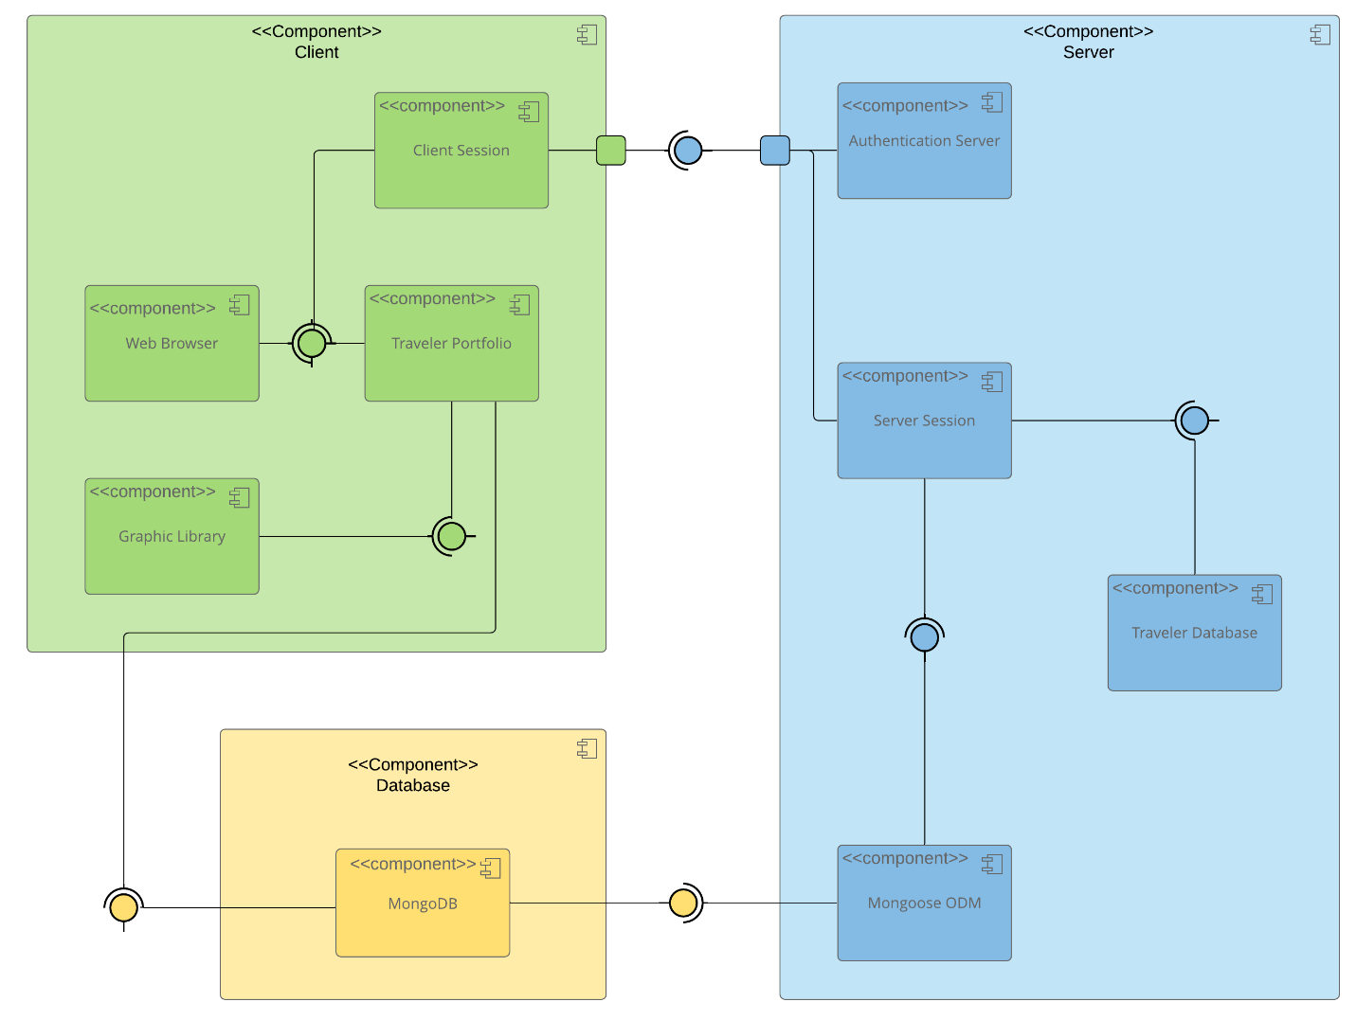

Sequence Diagram

<Illustrate the flow of logic in a web application by completing a sequence diagram. Insert an image of the sequence diagram here.>

<Describe the flow of logic in the web application based on the sequence diagram. Be sure to describe the interactions between the layers, or tiers, of the full stack application. It will be helpful to include significant processes such as Sign In, Trips, and Admin interactions when referring to the sequence diagram.>

Class Diagram

<Illustrate the JavaScript classes of the web application by completing a class diagram for the web application. Insert an image of the class diagram here.>
<Describe the JavaScript classes of the web application based on the class diagram.>

API Endpoints

<Exposing RESTful endpoints is a design approach to enable an application to participate in a larger ecosystem. Document each endpoint in the table below, including the HTTP method, purpose, URL, and notes.>

Method | Purpose | URL | Notes
GET | <Retrieve list of things> | </api/things> | <Returns all active things>
GET | <Retrieve single thing> | </api/things/:thingId> | <Returns single thing instance, identified by the thing ID passed on the request URL>

The User Interface

<Insert screenshots from the development of the SPA development to show the following: (1) a unique trip, added by you, (2) the Edit screen, and (3) the Update screen.>

<Summarize the Angular project structure and how it compares to the Express project structure. Be sure to describe the rich functionality provided by the SPA compared to a simple web application interaction. Describe the process of testing to make sure the SPA is working with the API to GET and PUT data in the database.>

